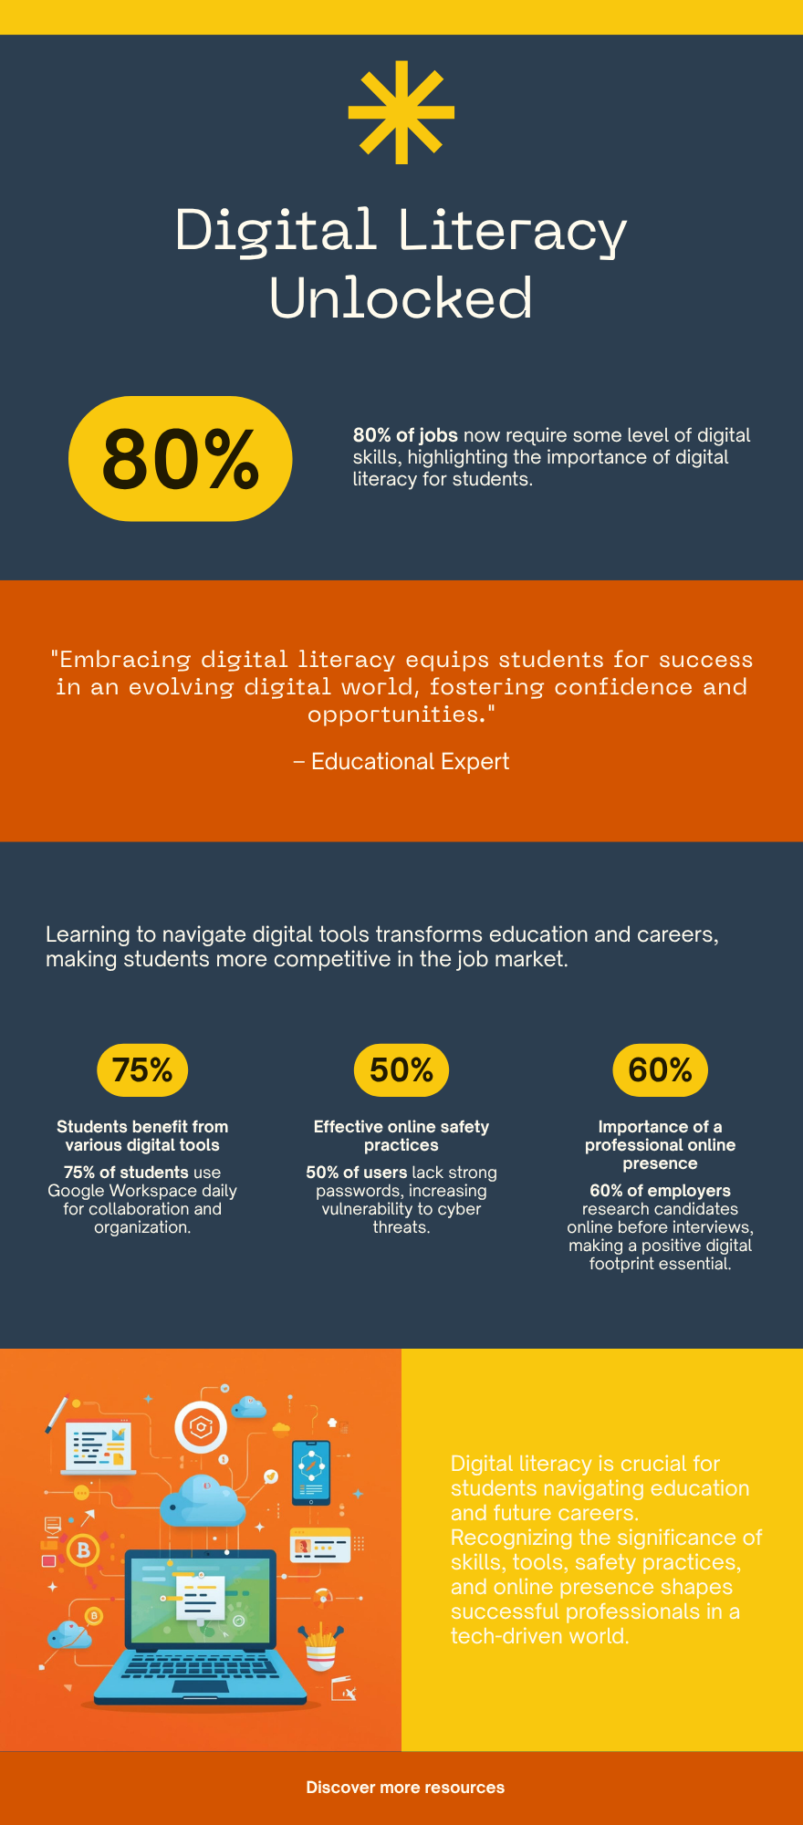
Task 1 Project Report To Create a Digital Literacy Awareness Infographic

For this task, I used Canva, a free browser-based graphic design tool, to create a one-page digital literacy infographic targeting my batchmates. The infographic is divided into four clearly labelled sections: What is Digital Literacy, which defines the concept and lists core competencies like information evaluation and digital communication; Useful Digital Tools for Students, highlighting platforms such as Google Workspace, Notion, and Grammarly; Safe Internet Practices, covering strong passwords, two-factor authentication, and avoiding phishing; and Professional Online Presence, with tips on maintaining a clean LinkedIn profile and personal branding online. The design uses vibrant colours, recognisable icons, and a student-friendly layout to make the content approachable. One thing I found interesting while making it was how much visual hierarchy matters — choosing the right font sizes and colours to guide a reader's eye across the page is a skill in itself, and it gave me a deeper appreciation for thoughtful design as part of digital literacy itself.

